**Data Structure &Algorithm (Lab)**

**Assignment # 02**

Name: Zeeshan(SU92-BSITM-F22-019)

Questions

**Question no 01:**  
1->2->3->4->5  
Given Linkedlist the head of a linked list,delete every alternate element from the list starting from the second eletement .

**Code:**  
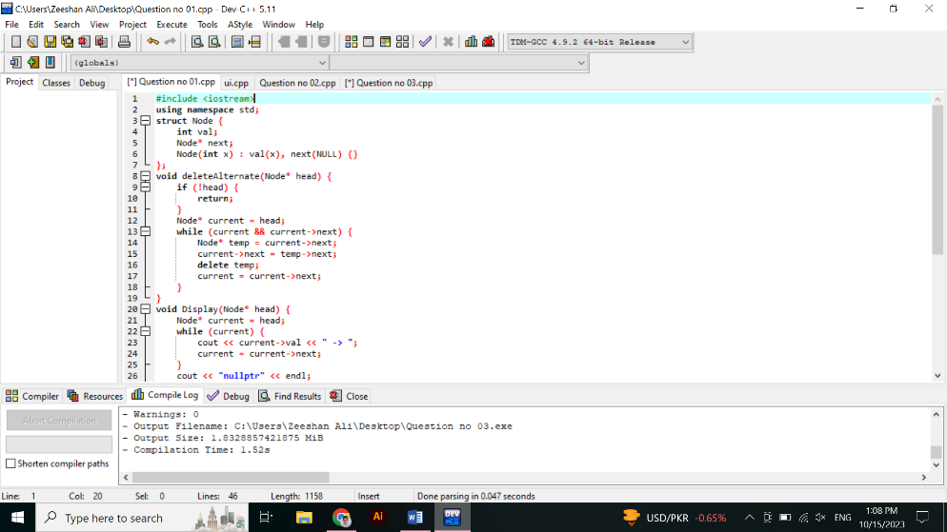

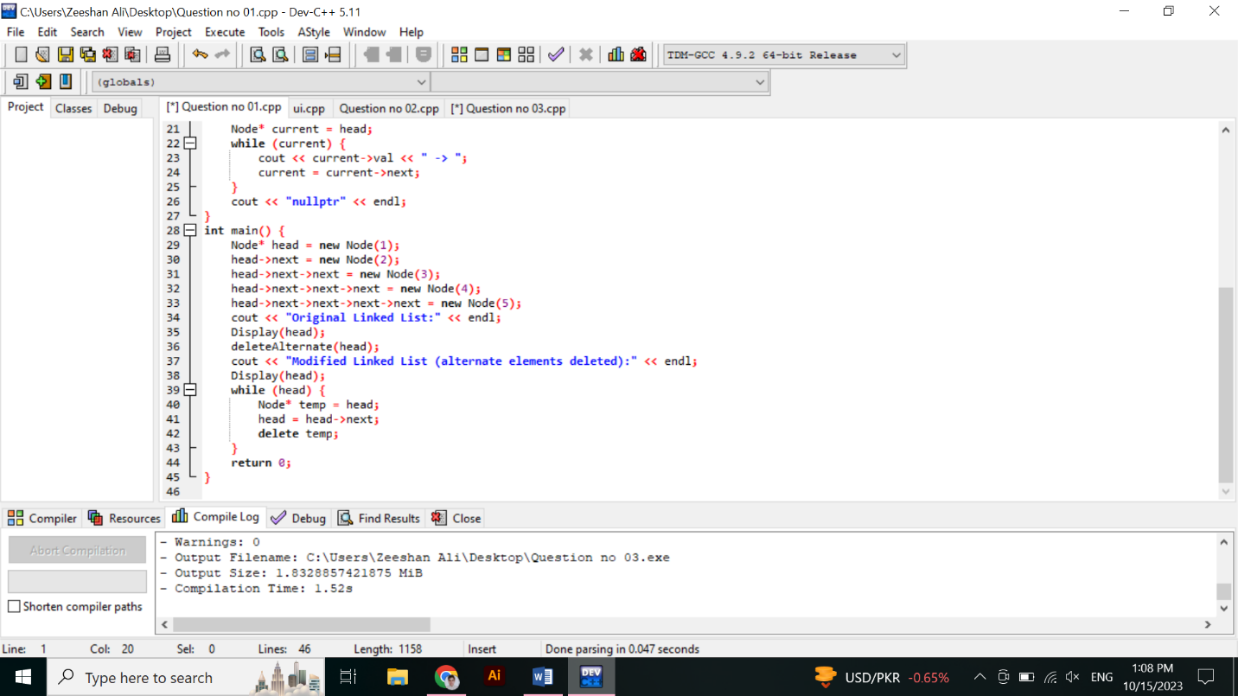

**Output:**

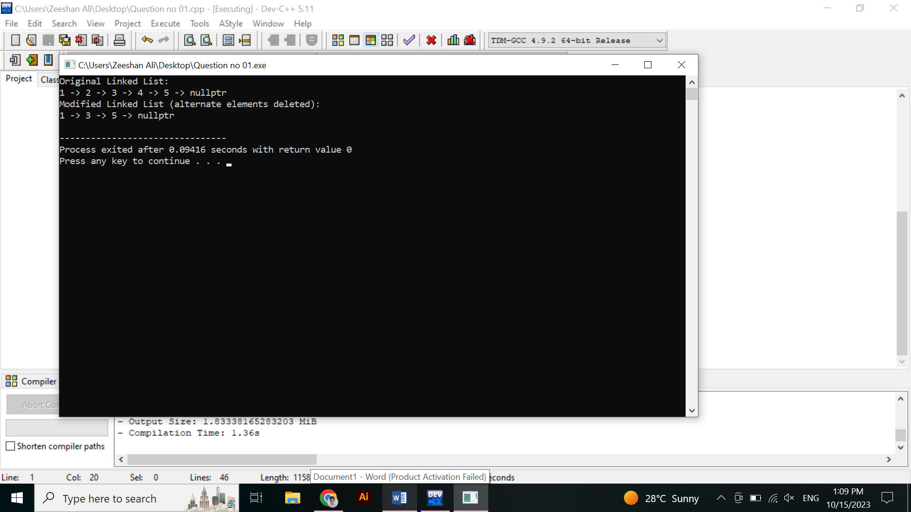  
**Question#2:**  
1->2->2->3->3->3  
Qiven the head of a sorted linked list,delete all duplicates such that each element appears only once.return the linked list sorted as well.

**Code:**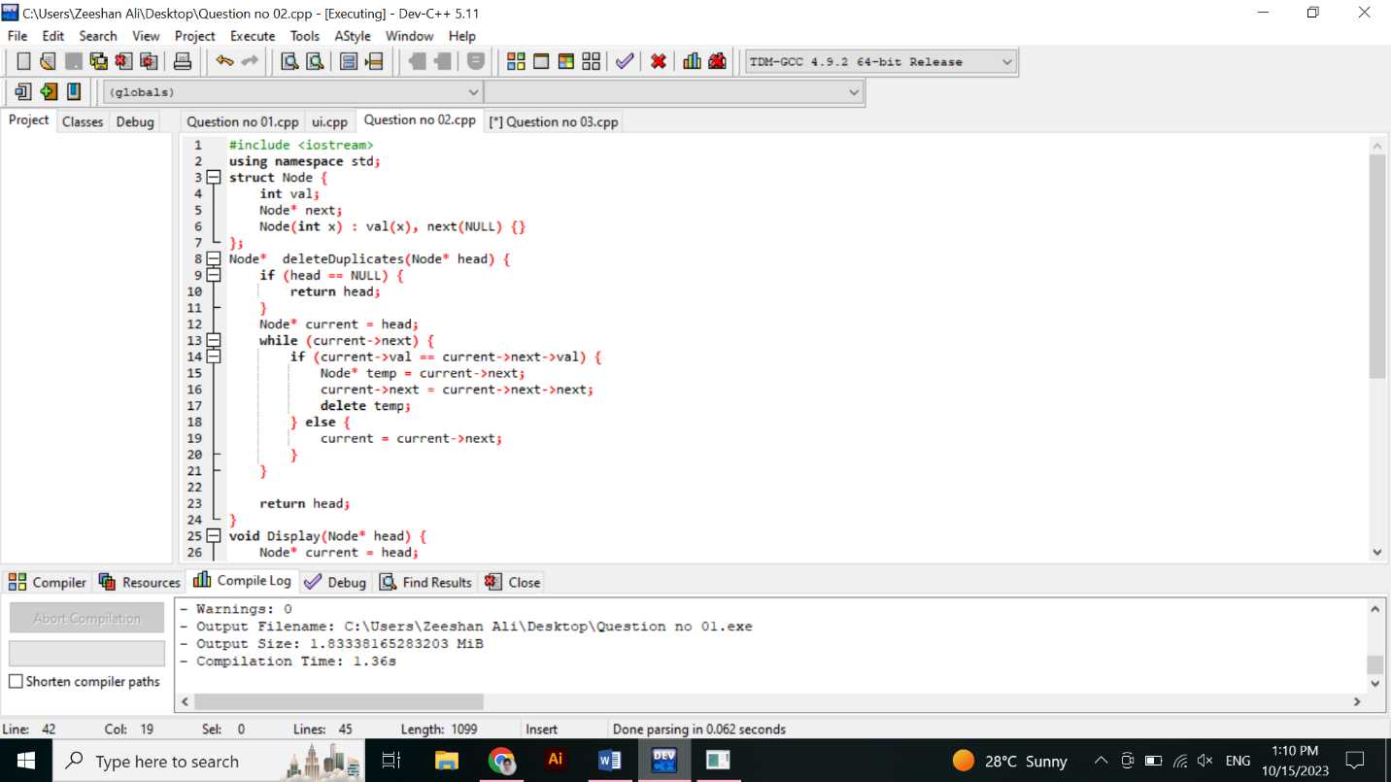

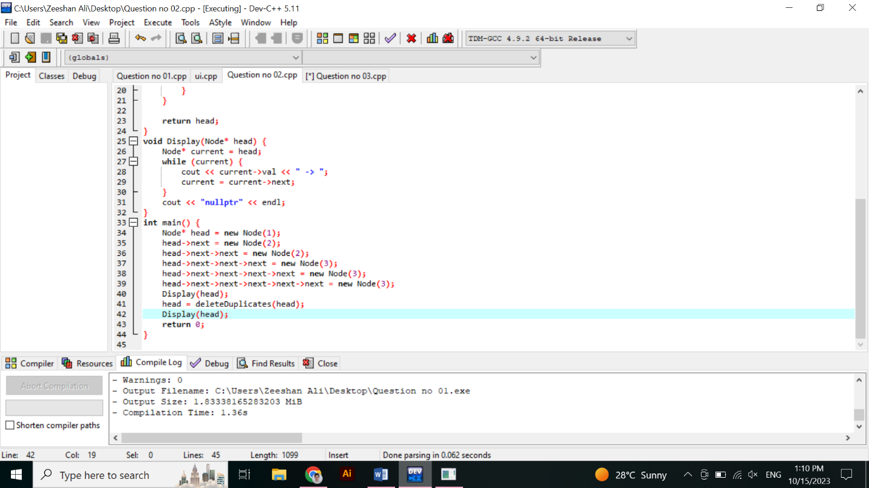**Result:**

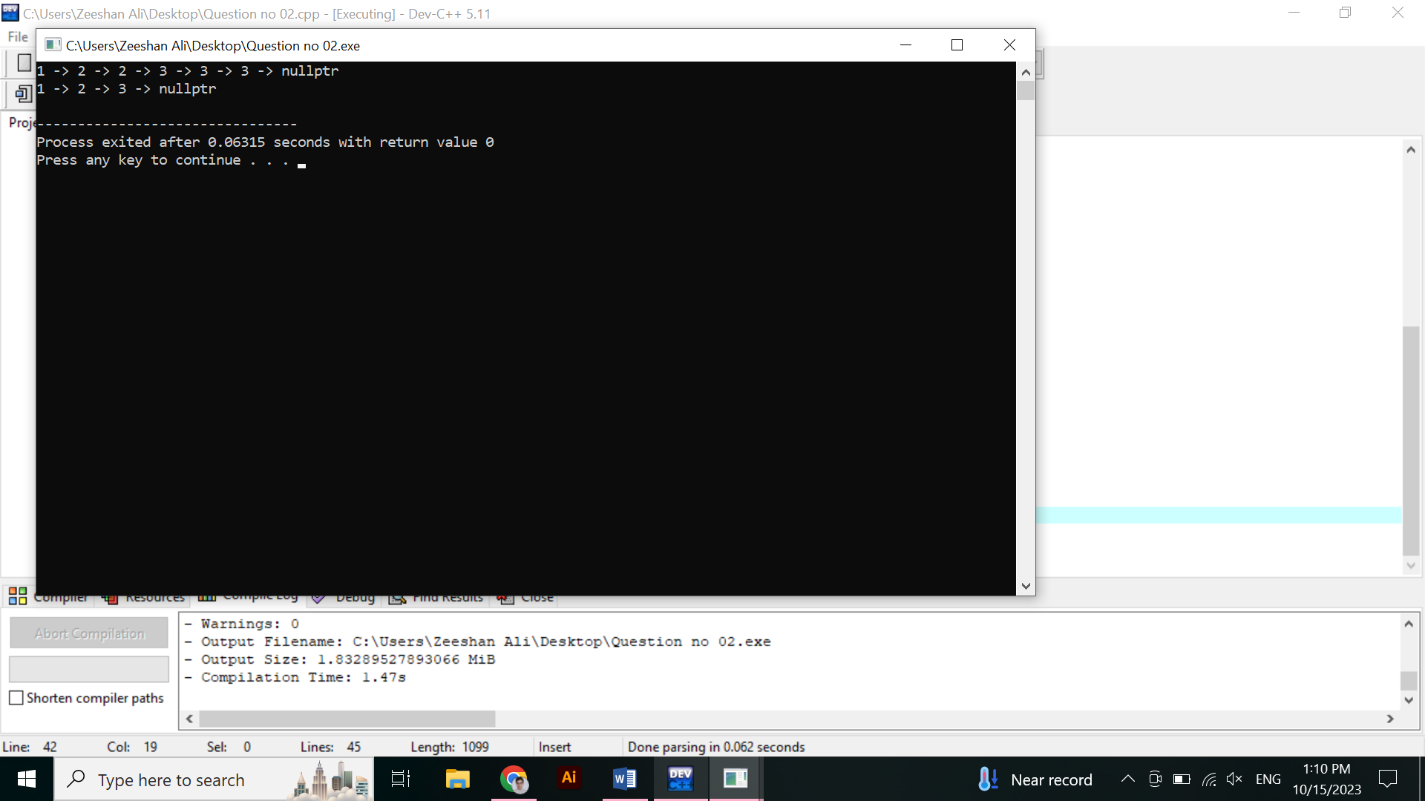  
**Question#3:**  
1->2->3->4  
Given the head of a singly linked list and print te Reversed list .

**Code:**

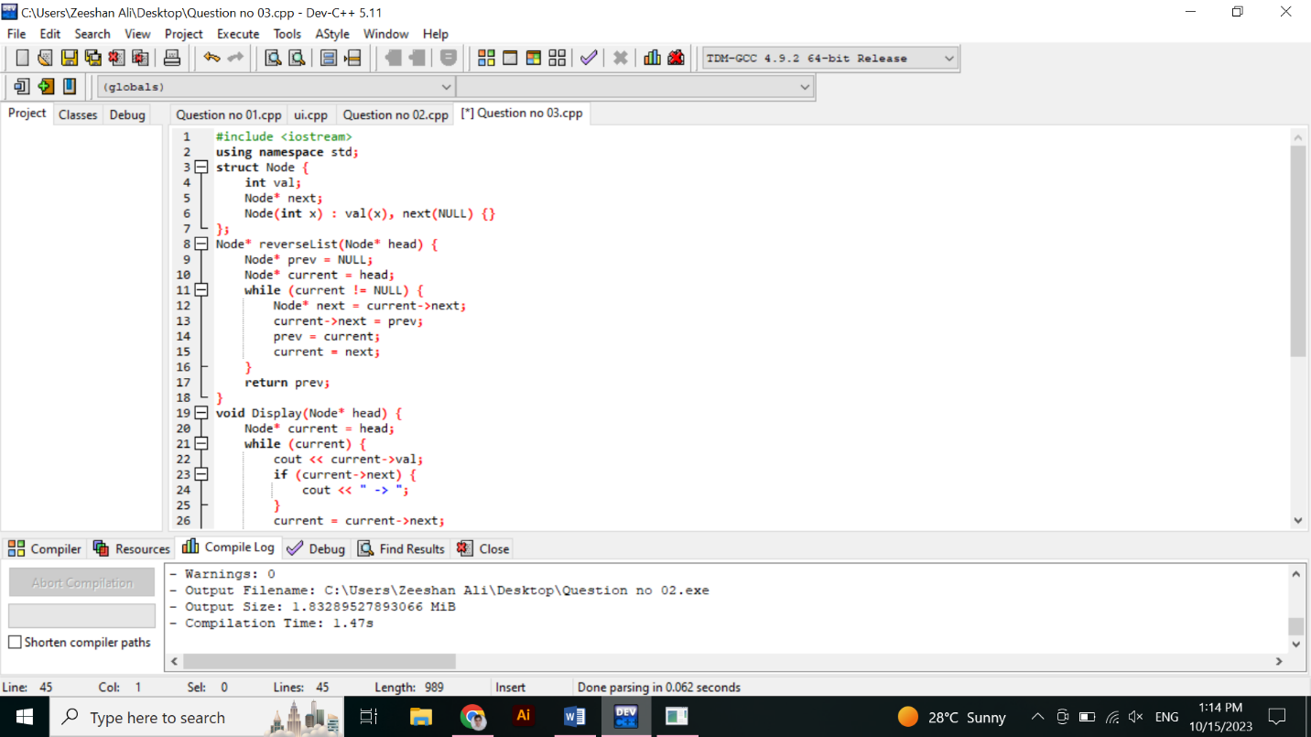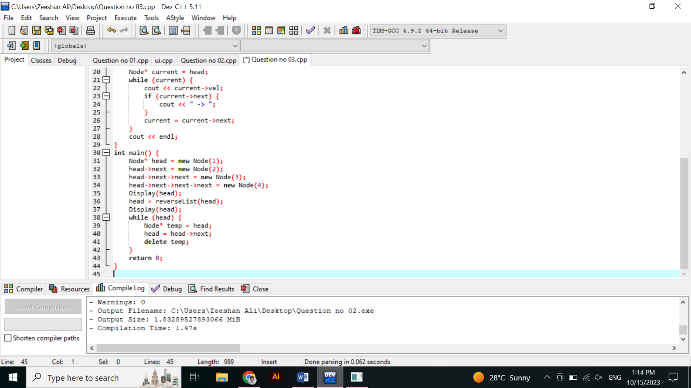

**Result:**